**1.converting roman numbers to integers.**

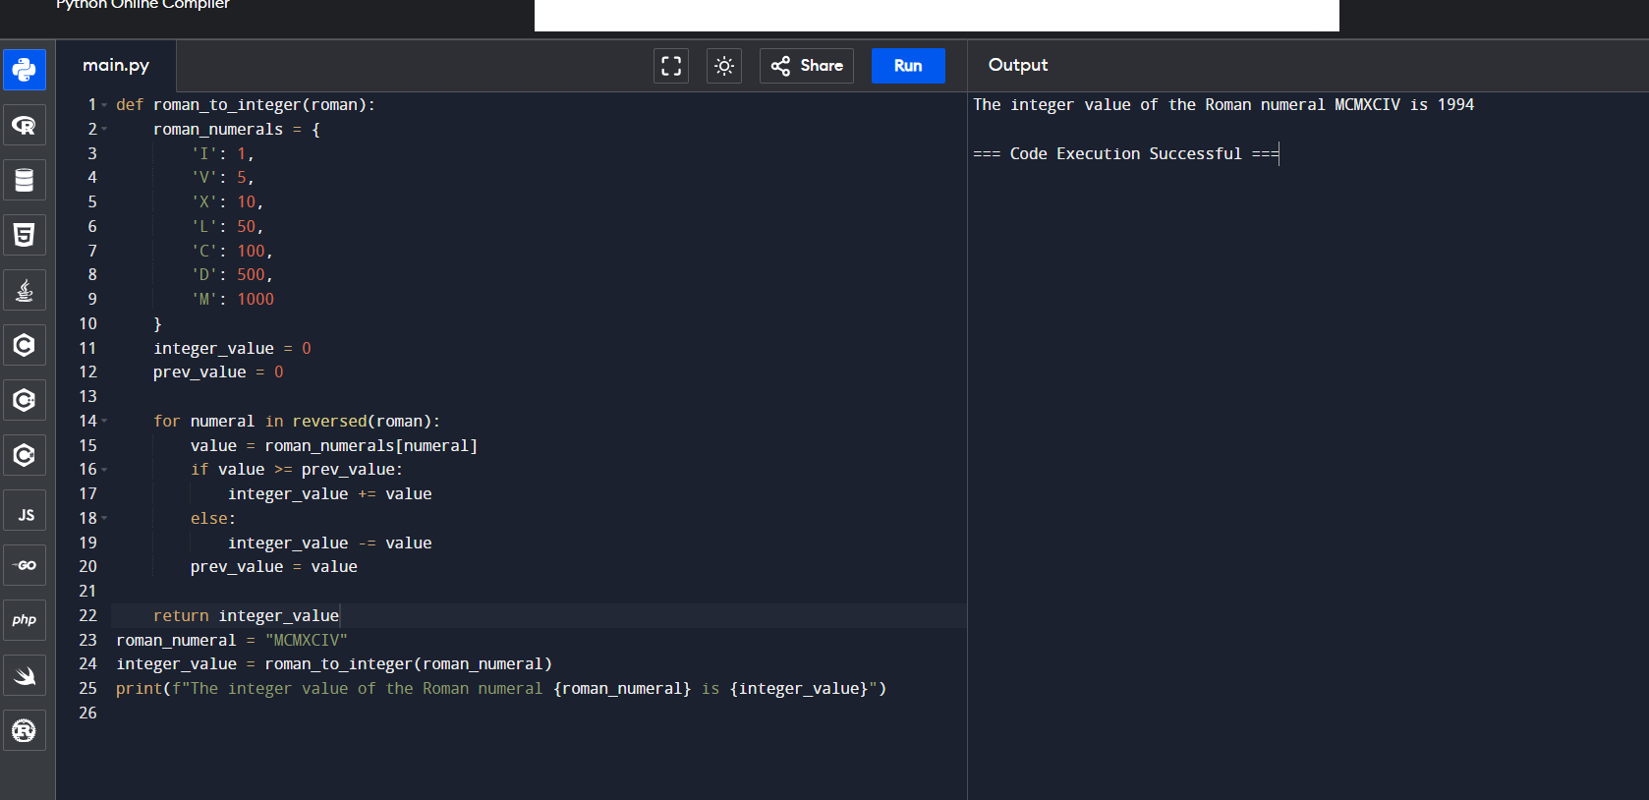

**2.write a function to find the longest common prefix string amongst an array of strings. “if there is no common prefix, return an empty string”.**

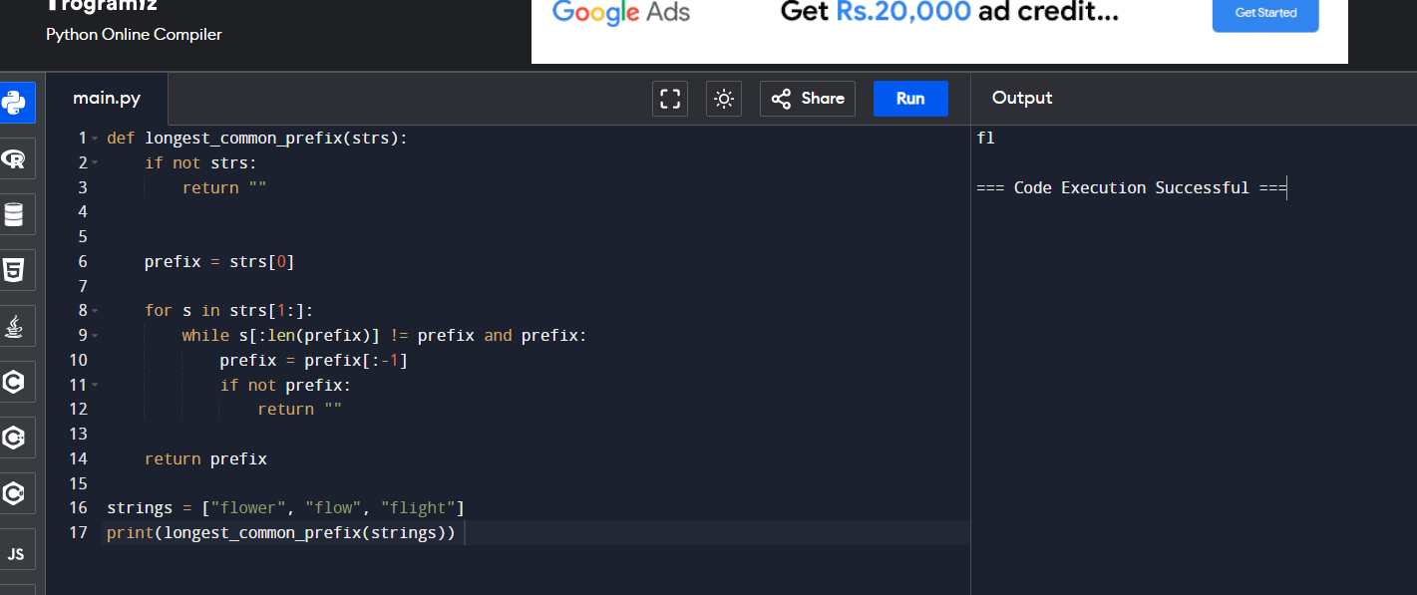

**3.Given the root of a binary tree and an integer sum return true if the tree has a root to leaf such that adding up all the values.**

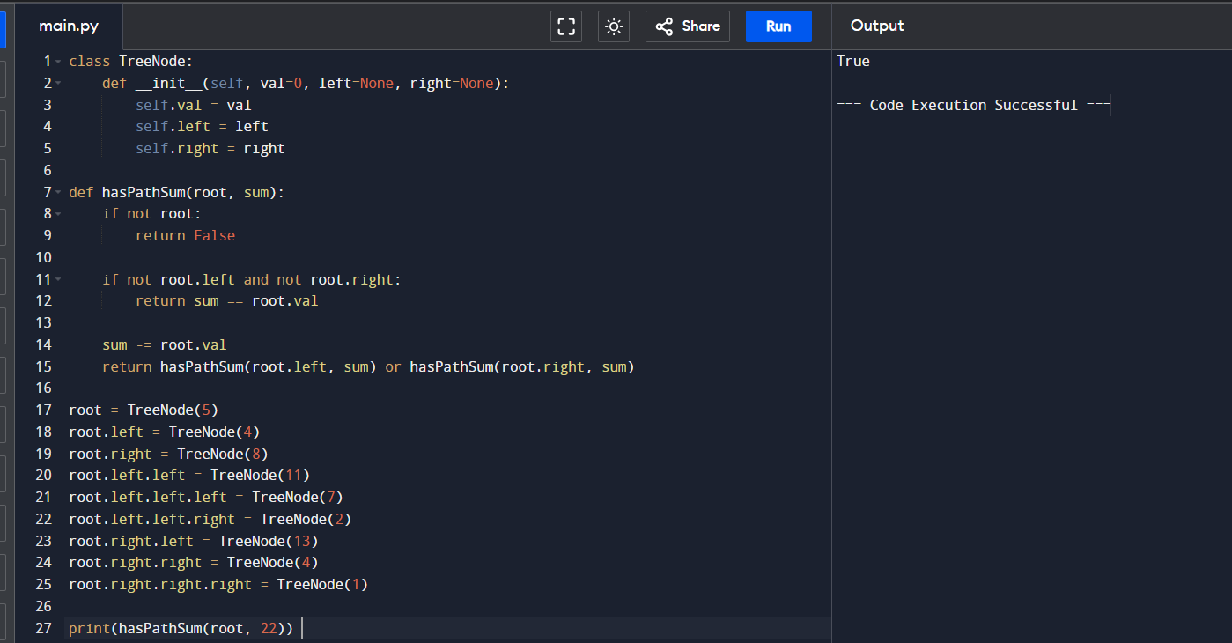

**4.Binary tree traversal.**

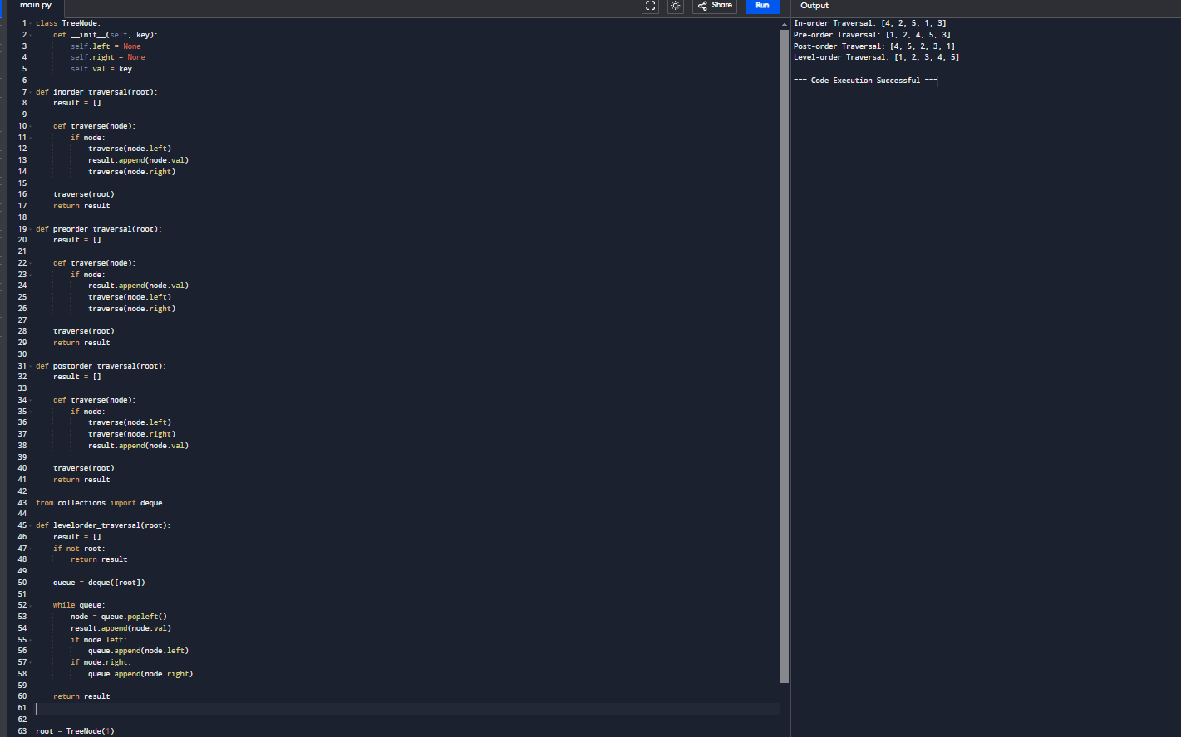

**5.Bit Reserving.**

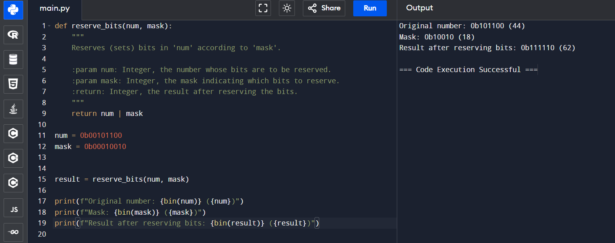

**6.convert sorted array to binary search tree give an integer array num where the elements are sorted in ascending order, convert it to a height-balanced.**

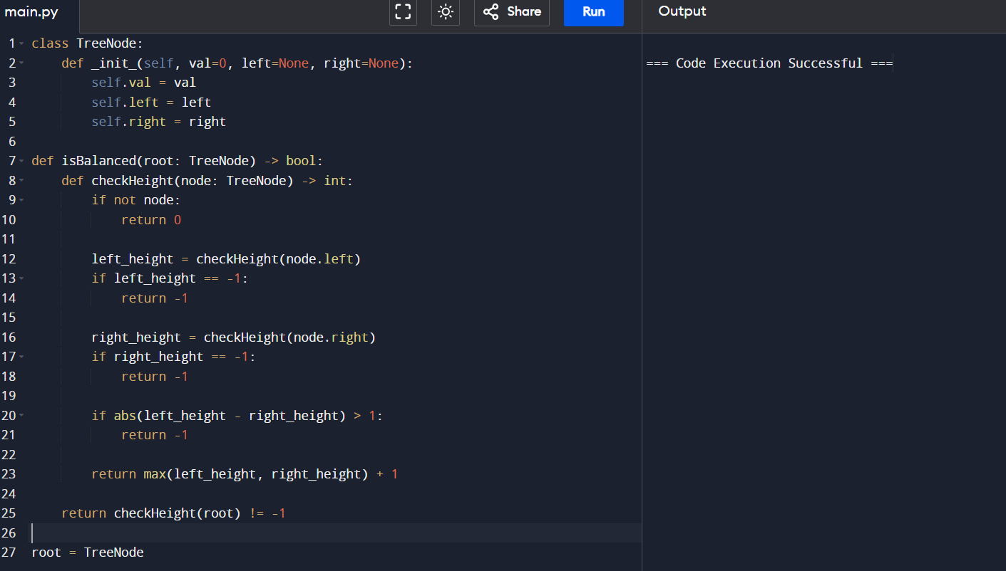

**7.Given a binary tree ,determine if it is heighted balanced.**

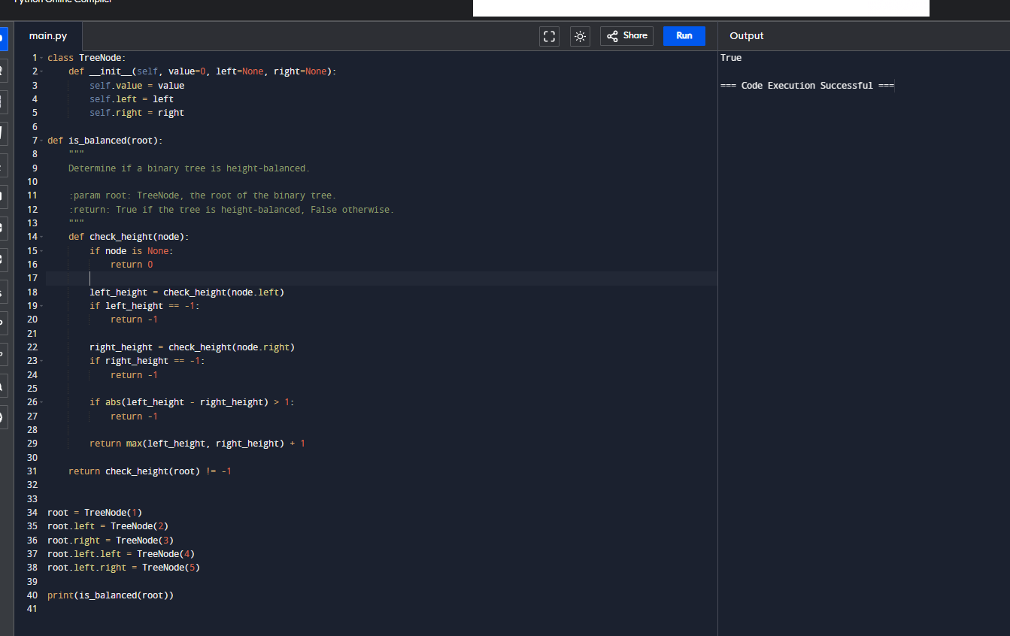

**8.Climbing stairs, your are climbing a staircase it takes n steps to reach the top.**

**Sach time you can either climb 1 or 2 steps.in how many distinct ways can you climb to the top?**

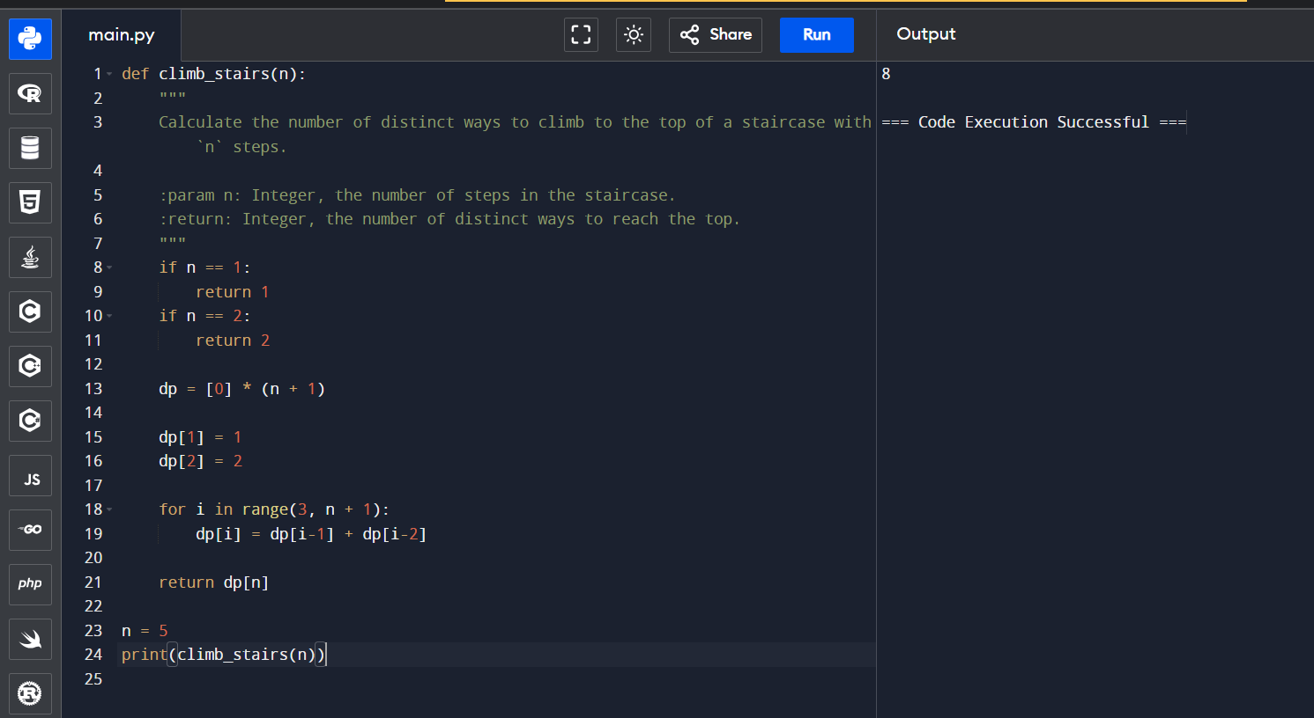

**9.** **Best these to buy and sell stock, you are given an array prices where prices[i] day. you want to max your profit by choosing a single day to buy one stock and choosing a diffrent day in the future to sell stocks.if you cannot achieve any profit ,return 0. give python programming.**

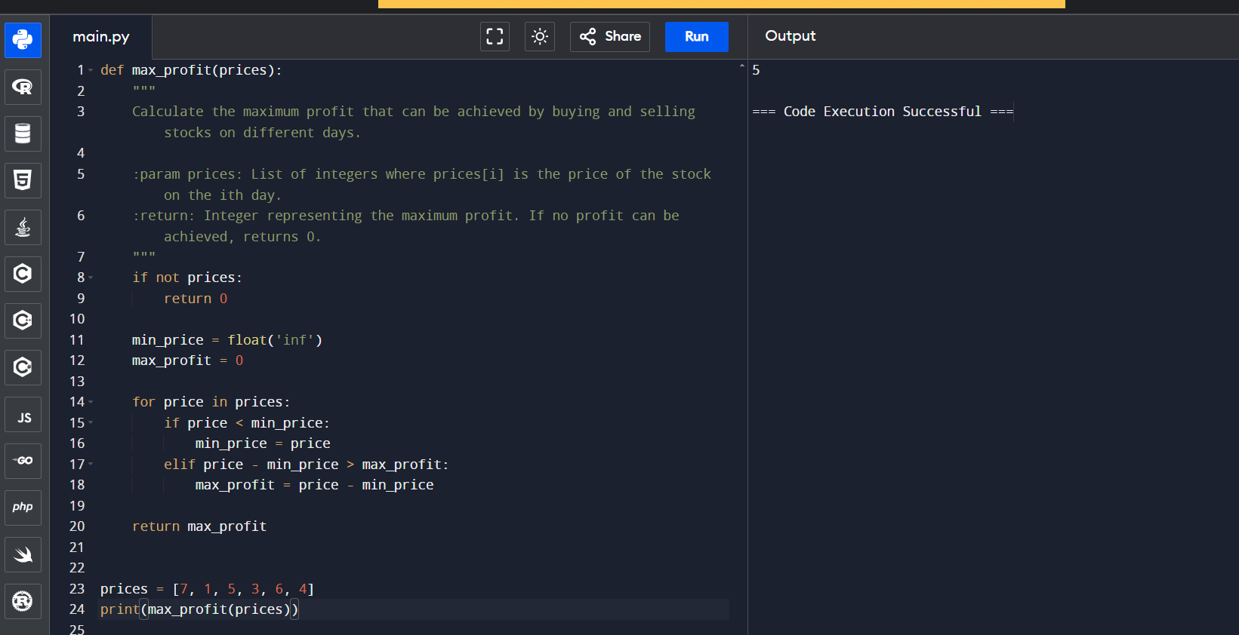

**10.** **Given two binary strings A and B ,return their sum as a binary string give python code.**

